**DAILY ONLINE ACTIVITIES SUMMARY**

|  |  |  |  |  |  |  |  |  |
| --- | --- | --- | --- | --- | --- | --- | --- | --- |
| **Date:** | **01/06/2020** | | | | | **Name:** | **V ANJANA PAI** | |
| **Sem & Sec** | **IV sem & B section** | | | | | **USN:** | **4AL18CS094** | |
| **Online Test Summary** | | | | | | | | |
| **Subject** | | **COMPLEX ANALYSIS, PROBABILITY AND STATISTICAL METHODS** | | | | | | |
| **Max. Marks** | | **30** | | **Score** | | | **30** | |
| **Certification Course Summary** | | | | | | | | |
| **Course** | **Cloud Foundations** | | | | | | | |
| **Certificate Provider** | | | **Greatlearning academy** | | **Duration** | | | **4.5 hours** |
| **Coding Challenges** | | | | | | | | |
| **Problem Statement1:** Given an array arr [] of size N and an integer K. The task is to find the count of subarrays such that each subarray has exactly K distinct elements.  **Problem Statement2:** Given an array of positive integers. Write a C Program to find the leaders in the array. | | | | | | | | |
| **Status: Executed** | | | | | | | | |
| **Uploaded the report in Github** | | | | | **YES** | | | |
| **If yes Repository name** | | | | | **lockdown-coding** | | | |
| **Uploaded the report in slack** | | | | | **YES** | | | |

Online Test Summary: 18MAT41 test was scheduled from 9:30am t0 10:10am. The portion for the IA was 5th module there were 20 questions (10Q for 1 mark and 10Q for 2 marks) and the time assigned was 40 minutes the questions were mcq type.

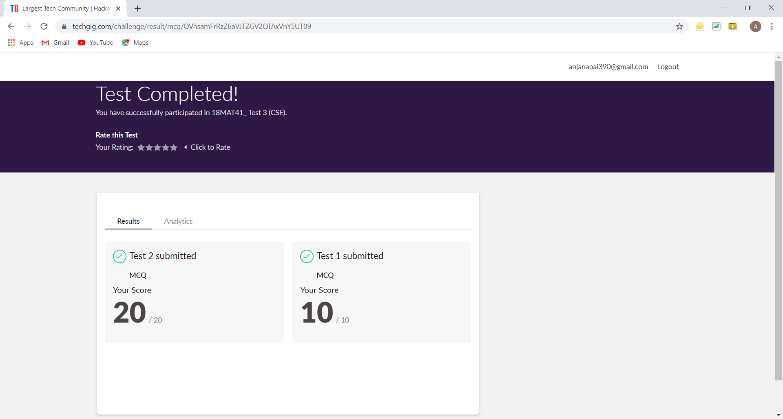

This is the snap shot of completion of test and the marks obtained in 18MAT41.

Online Certification Course Summary: In today’s session I learnt about Cloud Foundation Outline and the Module-1-Definations, Stories and Business Concerns.





These are the Snap shots of today’s sessions.

Online Coding Summary: **Today I had received one program from prof. Vasudev CSE Dept and another from prof. Venkatesh CSE Dept. The programs are mentioned above in the coding challenges(pg.01). I have also uploaded it to my Github repository.**

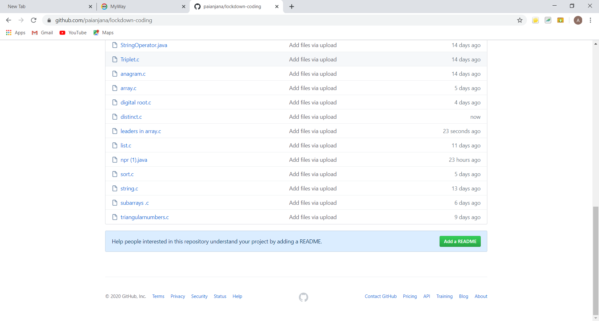

It is the snap shot of my repository where I have uploaded the code. File name is distinct.c and leaders in array.c